Doory: a smart mood reader.

# Easter: the best break for project management

Everyone knows that food helps productivity and creativity, then, the days before Easter holidays, between a colomba (an Italian Easter cake in form of a dove) and one other, have been the most profitable days for long project management session and long term planning of our work. We will not say too much about our plans, because everything will be revealed in the next blogs.

# Conrad Connect to improve our project

One of the most important feature that involved our planning sessions has been how to connect different smart devices, that we plan to use in our project, in a simple way. We found out the solution: Conrad Connect.

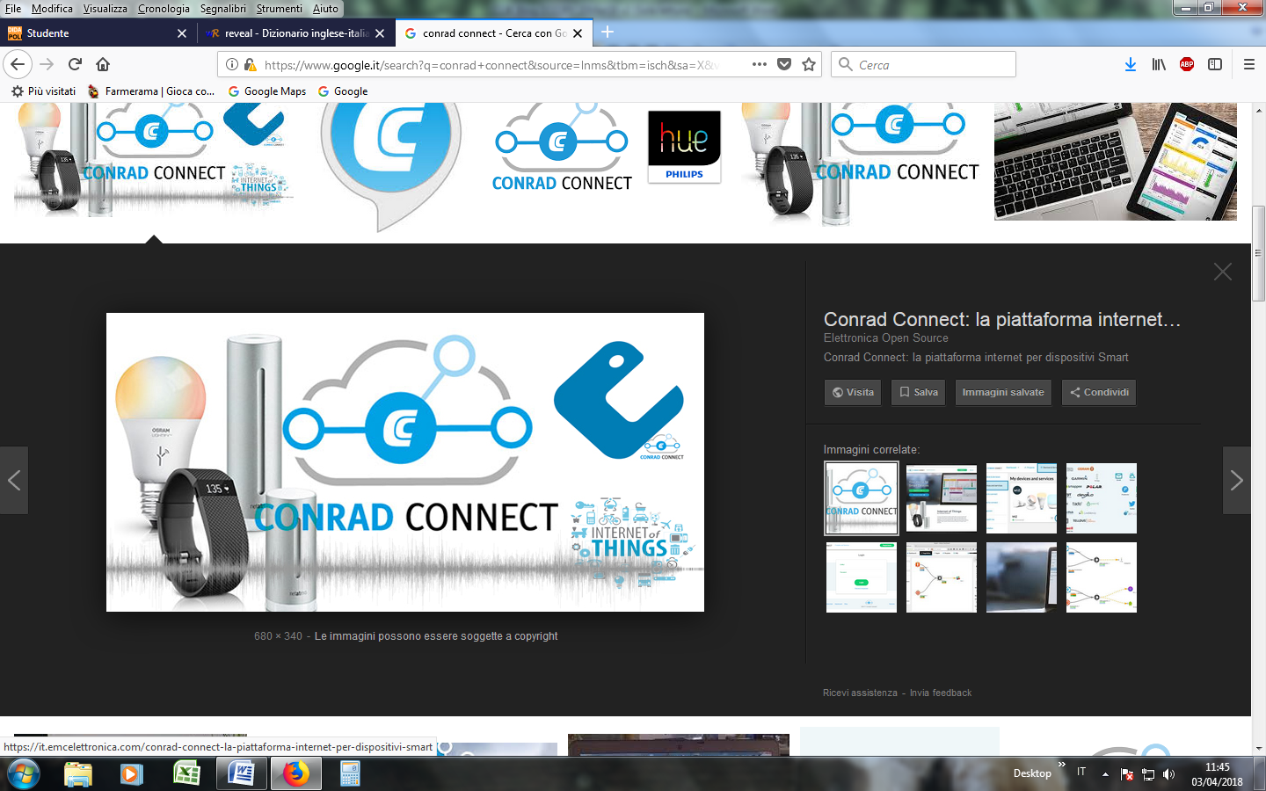

In particular we decided to use this technology to link the intelligence of our system, capable to detect the mood of the people, with the smart devices of the room in order to be able to create the most comfortable environment, personalized for your actual mood.

Furthermore, we decided to employ a subset of the smart devices, like an RGB led, compatible with the Conrad Connect, already on the next demo of our project.

[1] Conrad Connect: <https://conradconnect.de/en>

[2] Conrad Connect compatible devices: http://www.conrad.it/ce/it/Search.html?queryFromSuggest=true&search=conrad+connect

# A new mood for Doory

Our previous version of the project was based on this set of moods: "angry", "sorrow", "surprise", "happy".

We decided to refine this set, since, in most of our life we can be neither angry, or sorrow, or surprised or happy, but simply "normal". For this reason, we decided to improve our mood reader, in order to be able to detect even this mood.

# Python code testing and upgrade

After the hackathon, we continued to do testing on our demo version. Sometimes, a strange behavior has been detected: by doing an angry face, the result of our mood was that we were... "happy".

Yes, everyone knows that an engineering student is happy while he is doing long testing session of his prototype, but we decided to further investigate on this phenomena, and to find a solution.

Our solution was to improve our python script, based on a single mood reading in the previous version. In particular, we decided to use a multiple mood detection, and to perform a statistical analysis on the resulting data, giving to our system the intelligence to identify the possible outliers, and returning a more accurate result of the mood.

...

for i in range(0,3):

command = "cat out | grep " + likelihs[i] + " > response.txt"

os.system(command)

with open("response.txt", "r") as myfile:

data = myfile.readline()

list_data = data.split(": ")

for j in range(0,2):

if responses[j] in list_data[1]:

if j < mood_index:

mood = i

mood_index = j

mood_statistic[mood] = mood_statistic[mood]+1

maxim = -1

for i in range(0,4):

if(mood_statistic > maxim):

mood = i

maxim = mood_statistic[i]

...

# Our next goals

The first activity in which we will be involved after the Easter break, is to test and debug the new version of our Python code, that for sure will not work at the first attempt.

Furthermore we will define the app that we will use for our project.

Results of this activities will be part of the next blog. Stay tuned.

Follow up on the next Blog

#PoliTOCLIK #MorewithMouser @Conrad_Italia @StiffanConsult